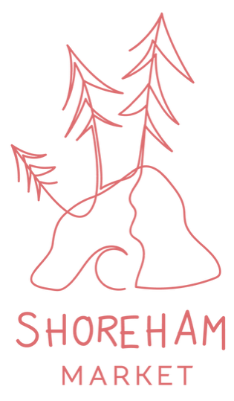

Stallholder Application Form

2023/24 Market Dates:
3rd Sunday of each month - 9am - 1pm
Sept 17, Oct 15, Nov 19, Dec 17, Jan 21, Feb 18, Mar 17, April 21 & May 19.

Location:
Shoreham Common - 67-85 Byrnes Road, Shoreham, VIC, 3916
On the corner of Byrnes and Cliff Rd (beside the tennis court)

Stall category & price (per market):
- Hot Food & Coffee - $150
- Local Business - $90
- Local Produce - $80
- Art & Craft - $70
- Second Hand - $60
- Community - $30
Please note:
- All stalls are 3x3 meters unless otherwise discussed.
- It is each stall-holders responsibility to bring their own stall set up.
- We aim to be a zero-waste market, if you do have any rubbish we ask that you manage and dispose of it yourself.
- There isn't an ATM in the area, so stallholders will need to come prepared

Please fill out the table below & email this document back to us at shorehammarket@gmail.com

Once your application has been accepted you will be sent payment details
& stallholder information.

Business name
Your product or service
Where are you based
Social Media links
Date(s) you are applying for
Stall category
Specific site requirements
(Size, Power, Shade, van…)
If food, do you have a food stall License? Please provide your Street Trader Reference No.
Do you have Public Liability Insurance?

*Please note - if you require power there will be an additional cost of
$15 per day.

