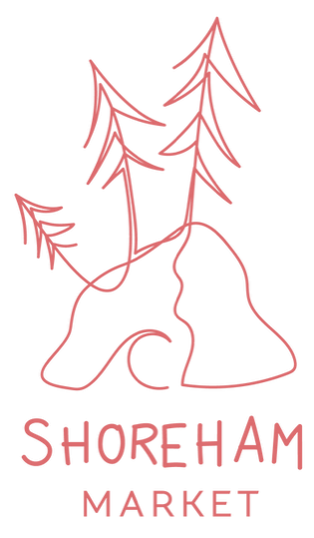

2025/2026 Season  
Stallholder Application Form

**Market Dates:**

Third Sunday of each month (Sep - May): 9am - 2pm

* Sep 21
* Oct 19
* Nov 16
* Dec 21
* Jan 18
* Feb 15
* Mar 15
* April 19
* May 17

**Location:**

Shoreham Common: 67-85 Byrnes Road, Shoreham, VIC, 3916 On the corner of Byrnes and Cliff Rd (beside the tennis court)

**Stall category & pricing (per market):**

* Hot Food & Coffee - $125
* Local Business - $80
* Local Produce - $70
* Art & Craft - $60
* Second Hand - $50
* Community & Children - Free

**Please note:**

* If you need power there is an additional cost of $15 per day
* *Due to the ^ number of stalls, some will need to book in month-to-month
* All stalls are 3mx3m unless otherwise discussed
* It is each stallholder’s responsibility to bring their own stall set up with **weights**
* There isn't an ATM in the area, so stallholders will need to come prepared

Please fill out the table below & email this document back to us at shorehammarket@gmail.com

Once your application has been accepted you will be sent confirmation and payment details.   
Payment is required to secure your position.   
Once payment has been received stallholder information will be sent.

*Please note - Art & Craft + some Local Bus will need to book in month-to-month

|  |  |
| --- | --- |
| Business name |  |
| Contact number |  |
| Your product or service |  |
| Where are you based |  |
| Social Media links |  |
| Date(s) you are applying for |  |
| Stall category (see list above) |  |
| Specific site requirements  (Size, Power, Shade, Location)  Power = $15 a day |  |
| Do you have Public Liability Insurance?  Please attach if applicable |  |
| **FOR FOOD HANDLERS** | **Our Food Philosophy**  To provide simple, healthy and local food at an affordable price for all. |
| What type of food are you serving |  |
| Do you have a food stall license? |  |
| Please provide your Statement of Trade Reference No. |  |